

**CHAPTER 7;OPERATORS**

Types

1. Arithmetic operators
2. Relational operators
3. Logical operators
4. Bitwise oparators

Example

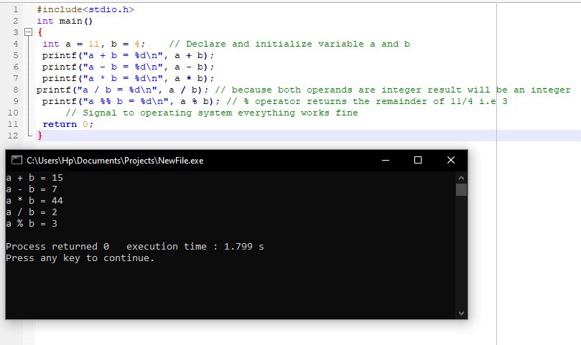

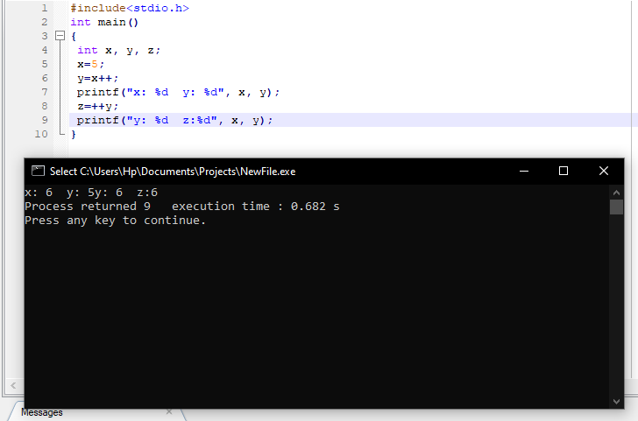

**CHAPTER 8 :DECISION MAKING**

**EXAMPLE:**

**IF…ELSE STATEMENT**

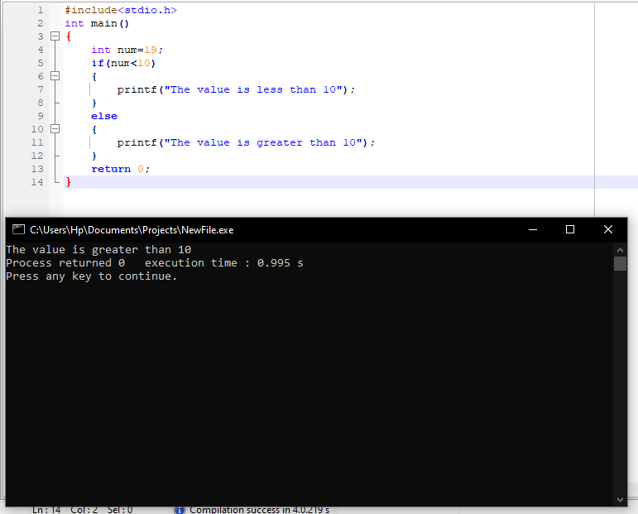

**CHAPTER 9:WORKING WITH LOOPS**

**WHILE LOOP EXAMPLE:**

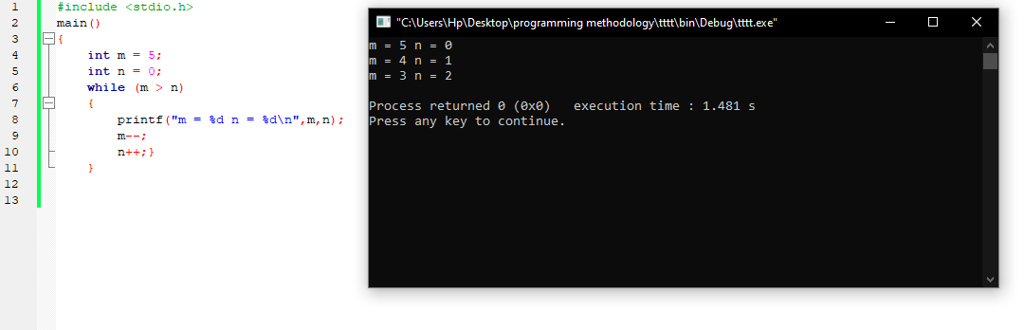

**CHAPTER 10:WORKING WTH FUNCTIONS**

EXAMPLE

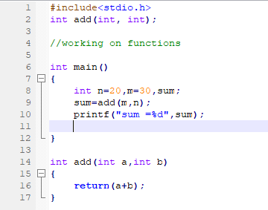

Output

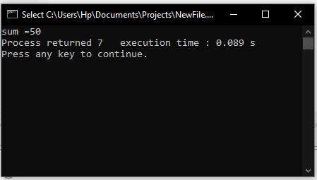

**CHAPTER 11:ARRAYS**

Declaring,initializing,accssing arrays

Example

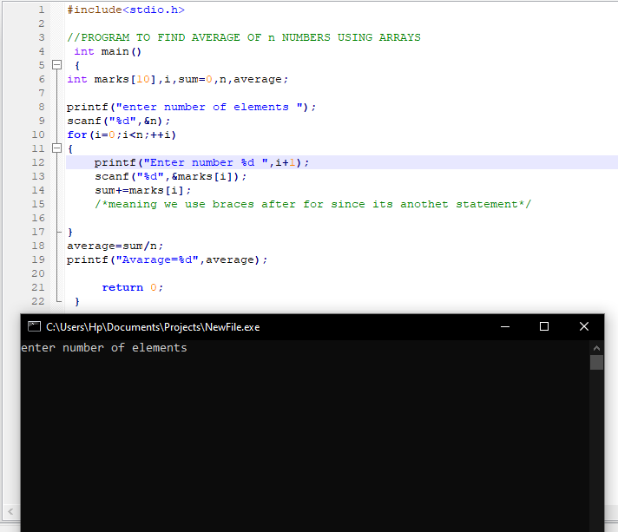

**CHAPTER 12:POINTERS**

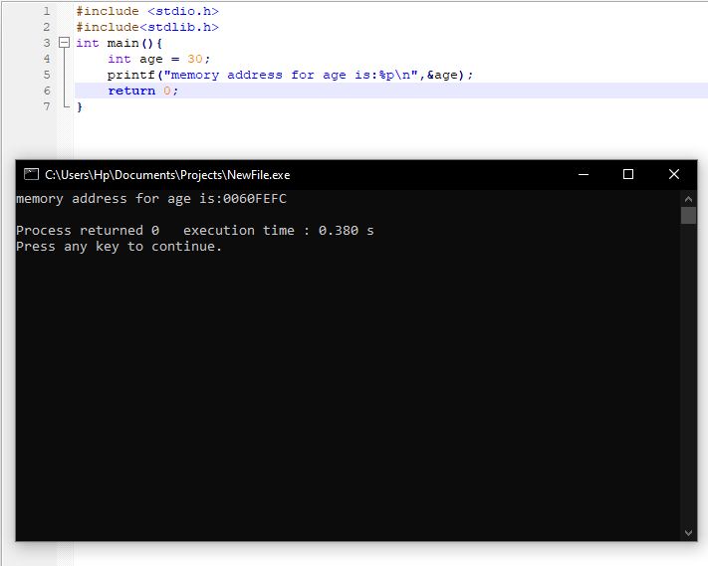

**CHAPTER 13:STRUCTURES**

Accessing structure members ,

defining structures members,

structures as function arguments

example

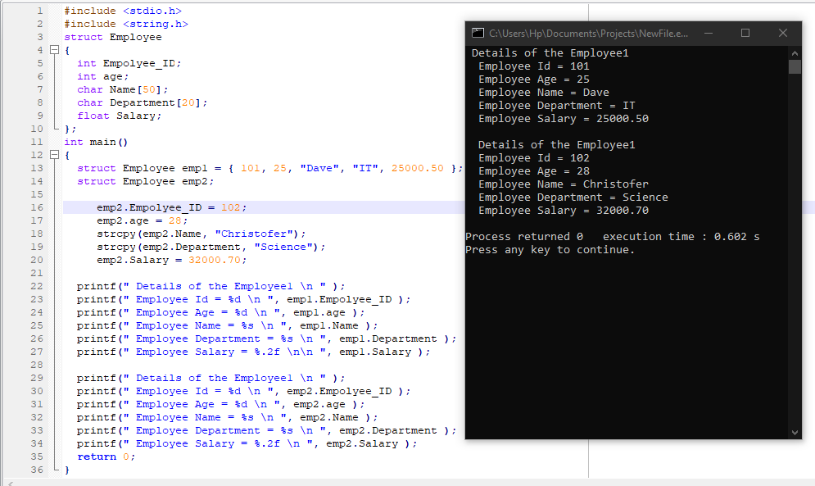

**CHAPTER 14:UNIONS IN C**

**EXAMPLES**

**Defining and accessing union members**

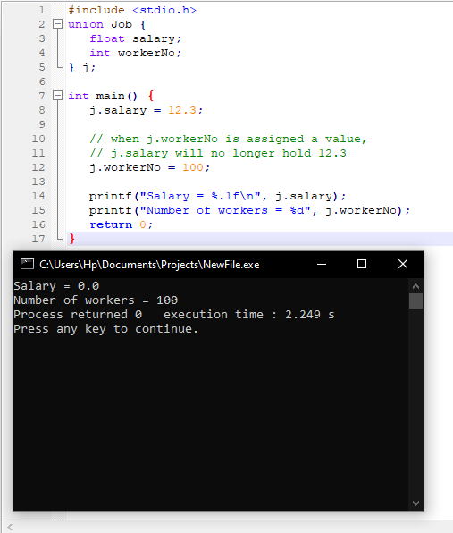

**DATA TYPES IN C**

**FLOAT DATA TYPE**

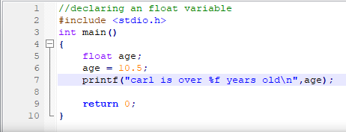

**OUTPUT**

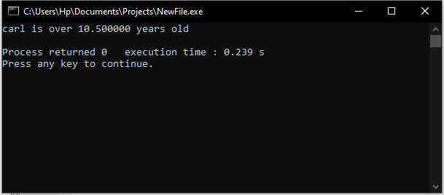

**INTERGER DATA TYPE**

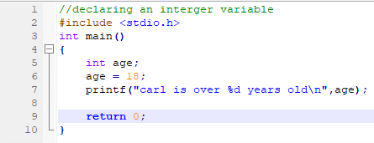

**OUTPUT**

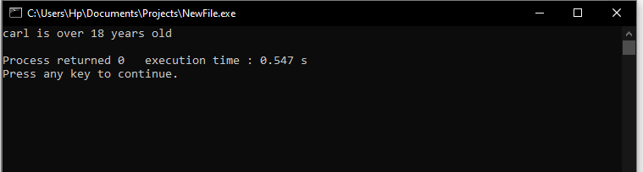

**HOW #INCLUDE WORKS**

**EXAMPLE**

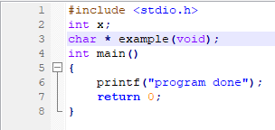

**OUTPUT**

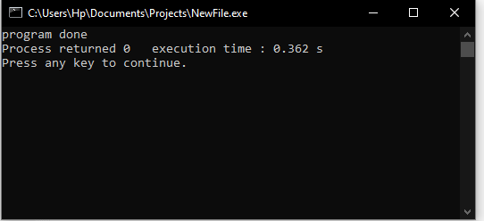

**GITHUB LINKS**